**Introduction to the power of Signal, Fourier Series, Square and Triangular Waves**

**LAB # 09**



**Spring 2021**

**CSE301L-Signal $ System**

Submitted by: **Ashfaq Ahmad**

Registration No: **19PWCSE1795**

Class Section: **B**

“On my honor, as student of University of Engineering and Technology, I have neither given nor received unauthorized assistance on this academic work.”

Student Signature: ______________

Submitted to:

**Engr Durr-e-Nayab**

July 2, 2021

**Department of Computer Systems Engineering**

**University of Engineering and Technology, Peshawar**

**OBJECTIVES OF THE LAB**

‐‐‐‐‐‐‐‐‐‐‐‐‐‐‐‐‐‐‐‐‐‐‐‐‐‐‐‐‐‐‐‐‐‐‐‐‐‐‐‐‐‐‐‐‐‐‐‐‐‐‐‐‐‐‐‐‐‐‐‐‐‐‐‐‐‐‐‐‐‐‐‐‐‐‐‐

In this lab, we will cover the following topics:

* Built in Matrix Functions
* Indexing Matrices • Sub Matrices
* Matrix element level operations
* Round Floating Point numbers to Integers ‐‐‐‐‐‐‐‐‐‐‐‐‐‐‐‐‐‐‐‐‐‐‐‐‐‐‐‐‐‐‐‐‐‐‐‐‐‐‐‐‐‐‐‐‐‐‐‐‐‐‐‐‐‐‐‐‐‐‐‐‐‐‐‐‐‐‐‐‐‐‐‐‐‐‐‐

**-------------------------TASK 01--------------------------**

* Calculate the power of discrete‐time cosine signal with period 20, defined over interval 0:19 using the following formula:

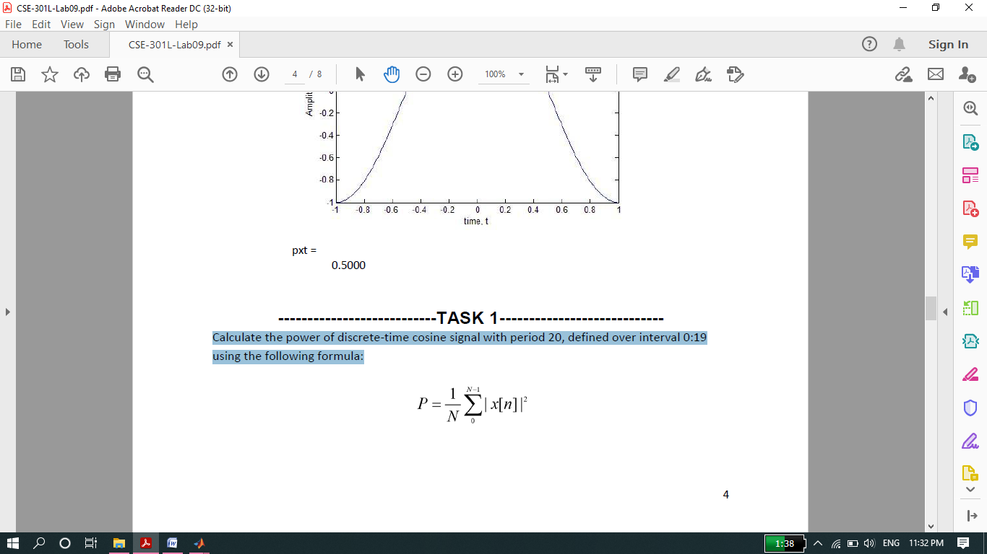

**Source code:**

clc

clear all

close all

disp('********Task 01*****');

n=0:0.01:18.99; %Duration or period of signal 0 to 19=20.

xn=cos(2*pi*n/2);

stem(n,xn);

xlabel('x-axis');

ylabel('y-axis');

title('Discrete time signal');

abs_xn_2=abs(xn).^2;

delta_n=0.01;

N=20;

power=sum(abs_xn_2)*delta_n/N

**OUTPUT:**

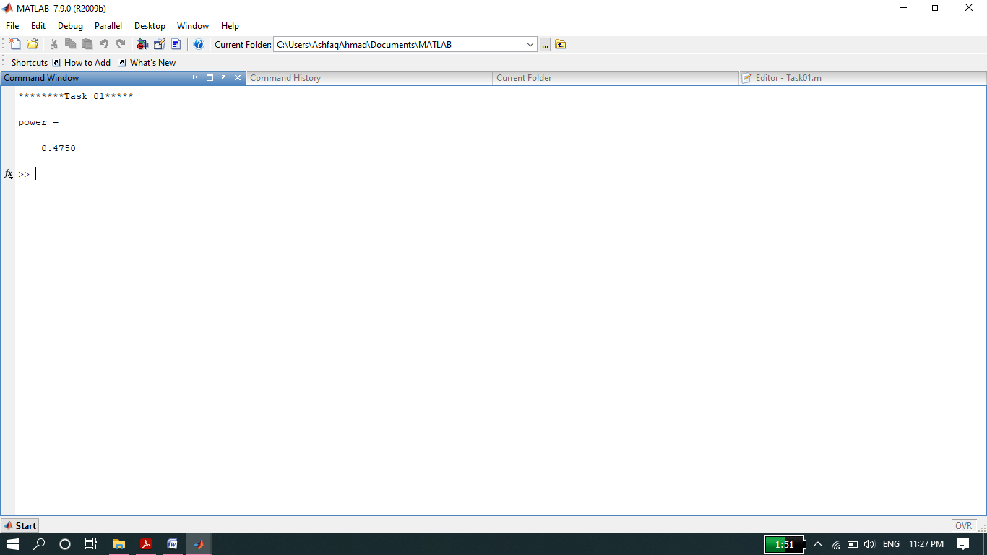

**Signal is:**

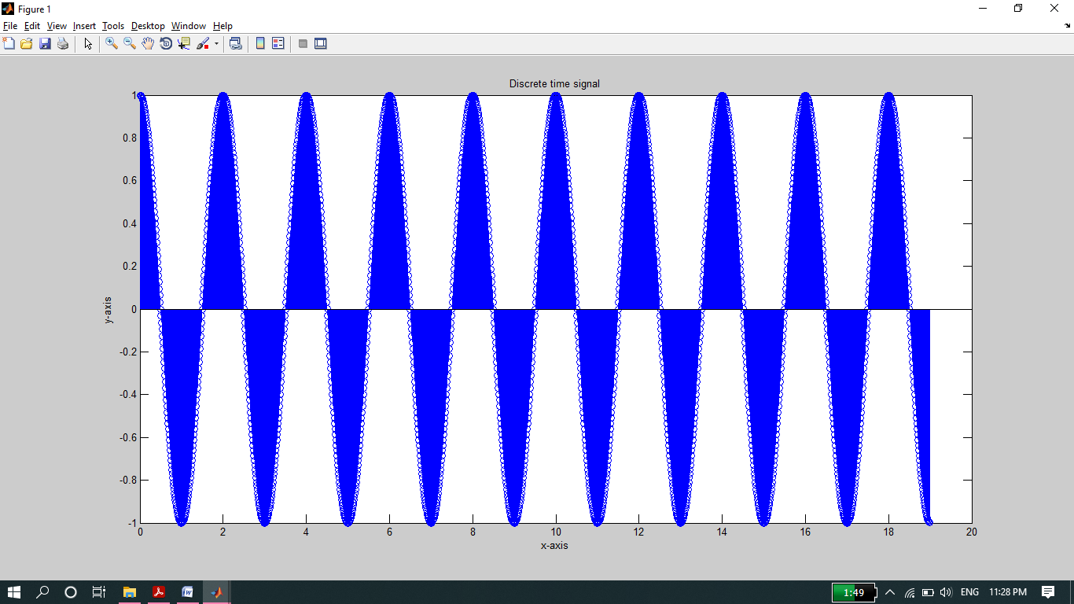

**-------------------------TASK 02--------------------------**

* Analyze the effect of Adding 1st to 17th harmonics and the effect of Adding 1st to 27th harmonics in above example.

**Source code:**

clc

clear all

close all

disp('**********Task 02***********');

t=0:0.008:8;

ff=0.5;

y=0;

i=1;

for k=1:2:17 %for loop for adding first to 17th odd hormonic.

fh=k*ff; %frequency changing in each iteration.

x=(4/(k*pi))*sin(2*pi*fh*t);

figure(1)

subplot(4,3,i)

plot(t,x);

title('single hormonic signal');

xlabel('Time-axis');

ylabel(k);

y=y+x;

i=i+1;

end

subplot(4,3,i+1)

plot(t,y,'Linewidth',2);

title('Effect of adding 1 to 17 odd hormonics result in Square signal');

xlabel('Time-axis');

ylabel('y-axis');

%up to this 1 to 17 odd hormonic added to y. Now we want to add 1 to 27 we

%will create another for loop and start it from 19 because 1 to 17 already

%added to y we will add 19 to 27 hormonics more in y then y will give us

%result of 1 to 27.

i=1;

for k=19:2:27

fh=k*ff;

x=(4/(k*pi))*sin(2*pi*fh*t);

figure(2)

subplot(2,3,i)

plot(t,x);

title('single hormonic signal');

xlabel('Time-axis');

ylabel(k);

y=y+x;

i=i+1;

end

subplot(2,4,i+1)

plot(t,y,'Linewidth',2);

title('Now Effect of adding first to 27 odd hormonics result in Square signal');

xlabel('Time-axis');

ylabel('y-axis');

**Output:**

* **1 to 17th Odd harmonics and sum result of 1 to 17th harmonics.**

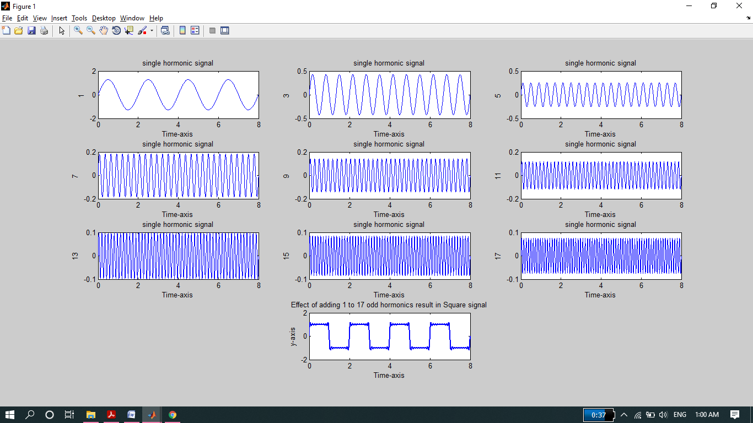

* **19th to 27th Odd harmonics and sum result of 1 to 27th harmonics.**

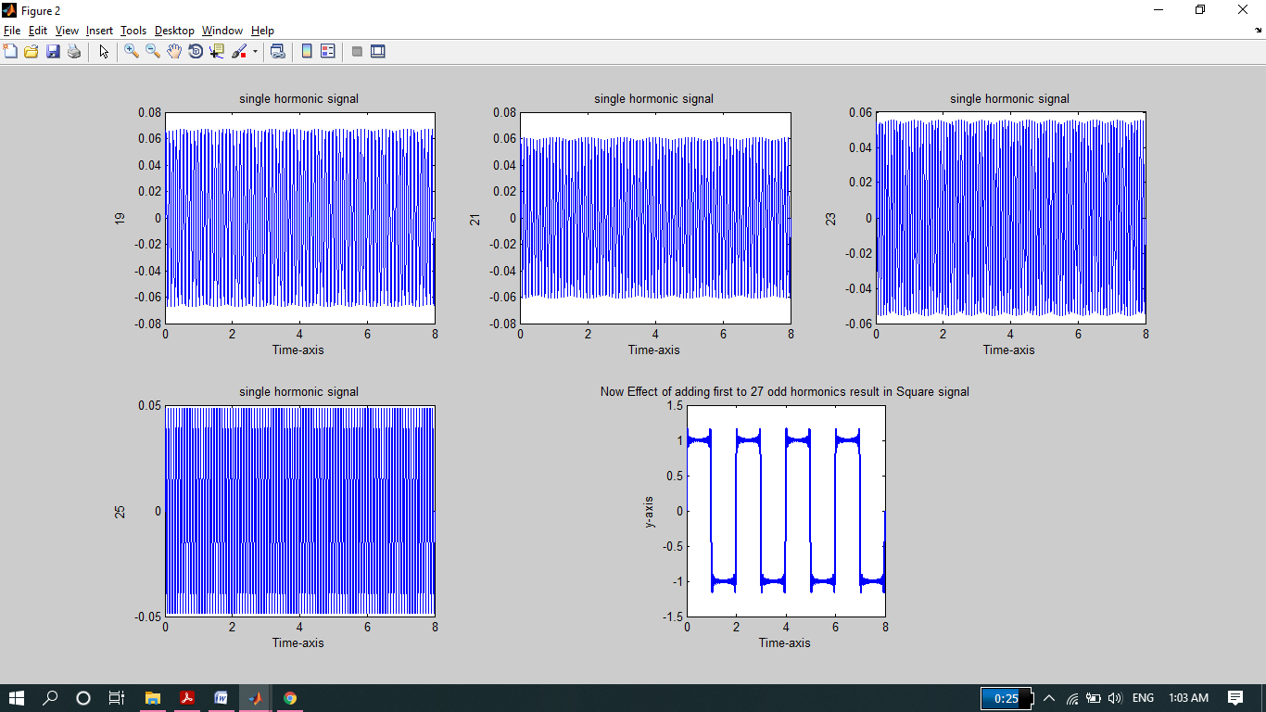

**-------------------------TASK 03--------------------------**

* Write a program that plots the signal s(t).



OR



What do you conclude from TASKS 2 & 3

**Source code:**

clc

clear all

close all

disp('*****Task 03******');

t=0:0.01:5;

sum=0;

i=1

for n=1:2:9 %frequency changing

xn=(sin(2*pi*n*t)/n);

sum=sum+xn;

figure(1)

subplot(3,2,i)

plot(t,xn);

title('single hormonic signal');

xlabel('Time-axis');

ylabel(n);

sum=sum+xn;

i=i+1;

end

figure(2)

plot(t,sum)

plot(t,sum,'Linewidth',2);

title('Effect of adding 1 to 9 odd hormonics result in Square signal');

xlabel('Time-axis');

ylabel('y-axis');

**Output:**

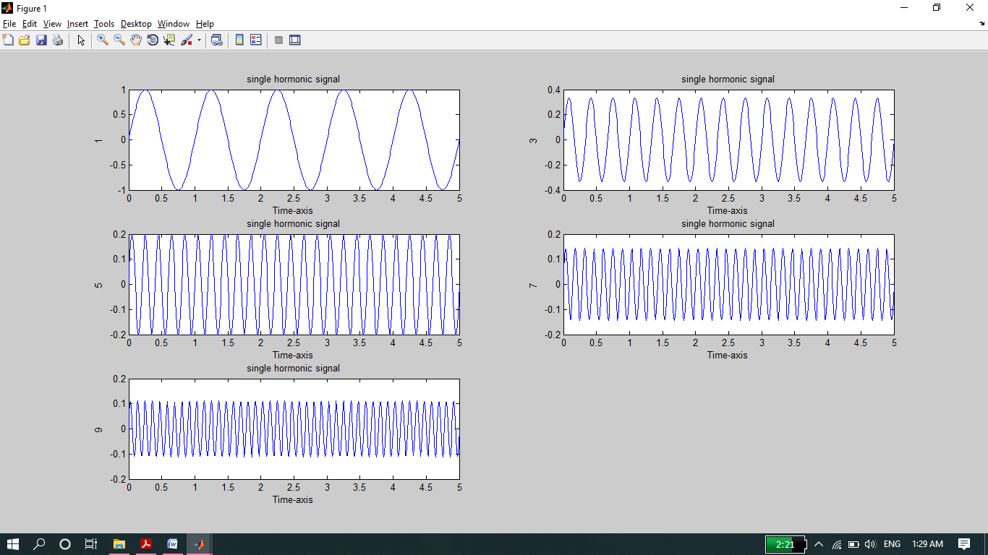

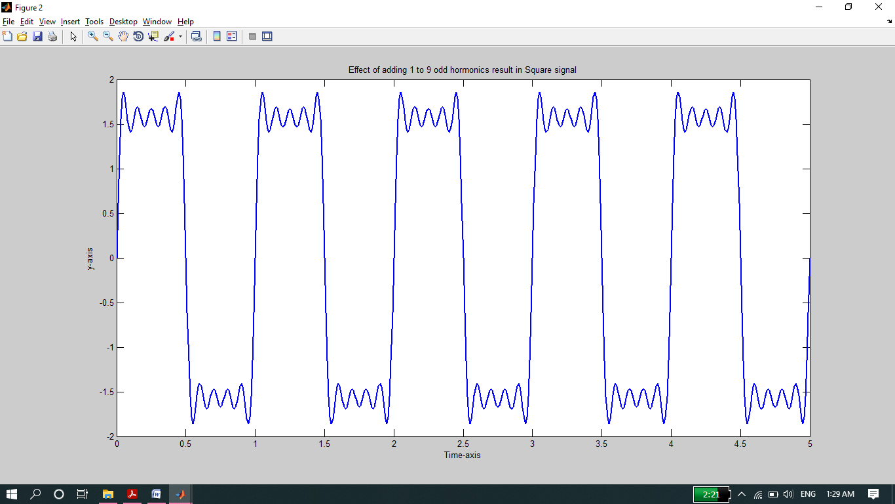

* The output of task 2 and 3 is almost same.

**-------------------------TASK 04--------------------------**

* Generate a **triangular wave with N=1**

**Source Code:**

clc;

clear all;

close all

disp('*********Task 04*********');

t=0:0.001:5;

x=(-8/(pi*pi))*exp(i*(2*pi*0.5*t));

y=(-8/(9*pi*pi))*exp(i*(2*pi*0.5*11*t));

s=x+y;

plot(t,real(s),'linewidth',3);

title('Triangular Wave with N=11');

ylabel('Amplitude');

xlabel('Time')

grid on

**Output:**

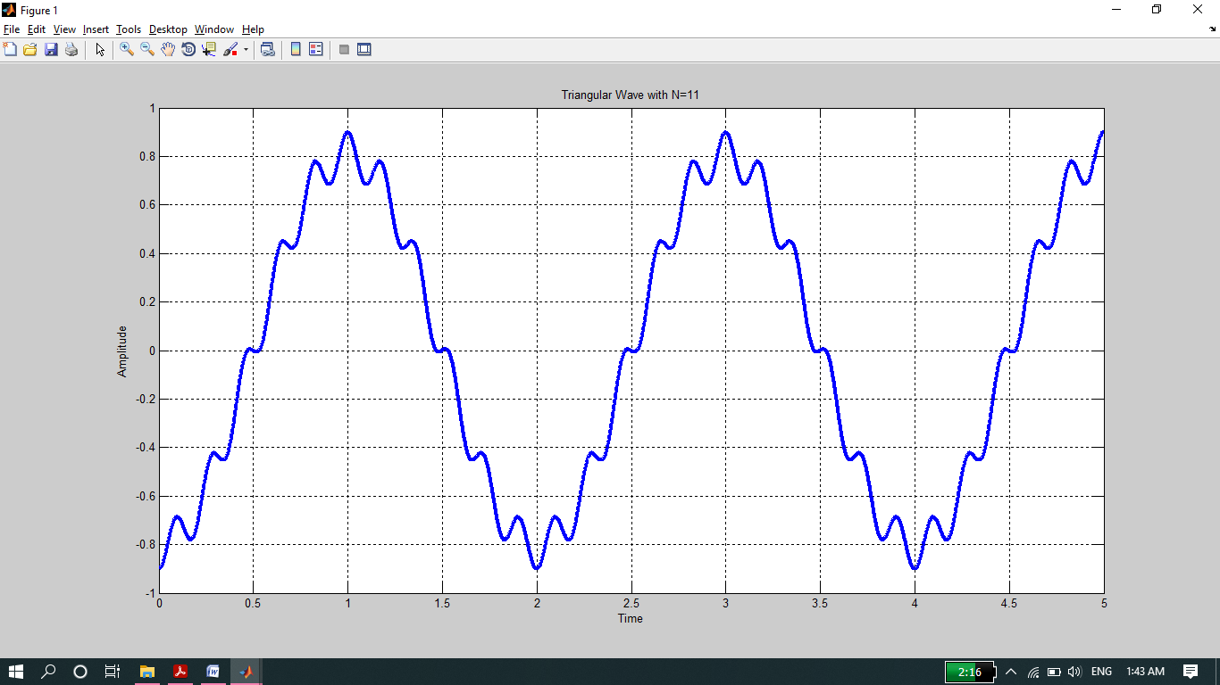

Prepared By Ashfaq Ahmad

THE END